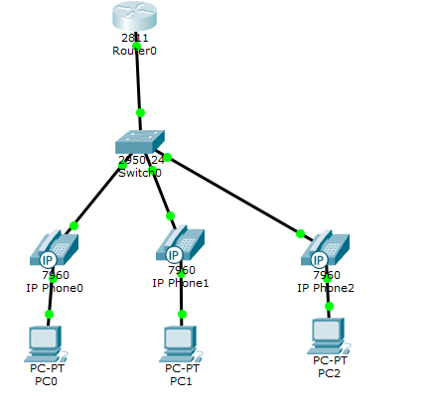

**Configuración:**

**Configurar DHCP**

**Router1(config)#ip dhcp excluded-address 192.168.0.1 192.168.0.10  
Router1(config)#ip dhcp pool VOICE   
Router1(dhcp-config)#network 192.168.0.0 255.255.255.0  
Router1(dhcp-config)#default-router 192.168.0.1  
Router1(dhcp-config)#option 150 ip 192.168.0.1**

**Router1(config)#ip dhcp excluded-address 192.168.1.1 192.168.1.10  
Router1(config)#ip dhcp pool DATA  
Router1(dhcp-config)#default-router 192.168.1.1  
Router1(dhcp-config)#network 192.168.1.0 255.255.255.0**

**Configurar Switch**

**S1(config)#vlan 10  
S1(config-vlan)#name VOICE  
S1(config-vlan)#vlan 20   
S1(config-vlan)#name DATA  
S1(config-vlan)#exit**

**S1(config)#interface fast 0/1  
S1(config-if)#switchport mode trunk  
S1(config-if)#exit   
S1(config)#interface range fastEthernet 0/2-10  
S1(config-if-range)#switchport mode access  
S1(config-if-range)#switchport access vlan 20  
S1(config-if-range)#switchpor voice vlan 10  
S1(config-if-range)#spanning-tree portfast**

**Configurar las subinterfaces y el encapsulamiento**

**R1(config)#interface fastethernet 0/0.1  
R1(config-subif)#encapsulation dot1q 10  
R1(config-subif)#ip address 192.168.0.1 255.255.255.0  
R1(config-subif)#description VOICE  
R1(config-subif)#exit  
R1(config)#interface fastethernet 0/0.2  
R1(config-subif)#encapsulation dot1q 20  
R1(config-subif)#ip address 192.168.1.1 255.255.255.0  
R1(config-subif)#description DATA  
R1(config-subif)#exit  
R1(config)#interface fastEthernet 0/0  
R1(config-if)#no shutdown**

**Encendemos los teléfonos es decir les agregamos la fuente de poder**

**En las PC les habilitamos la opción DHCP**

**R1(config)#telephony-service  
R1(config-telephony)#max-dn 5  
R1(config-telephony)#max-ephone 5  
R1(config-telephony)#auto assign 1 to 5  
R1(config-telephony)#ip source-address 192.168.0.1 port 2000**

**Creamos el directorio Telefonica**

**R1(config)#ephone-dn 1  
R1(config-ephone-dn)#number 1001  
R1(config-ephone-dn)#exit  
R1(config)#ephone-dn 2  
R1(config-ephone-dn)#number 1002  
R1(config-ephone-dn)#exit  
R1(config)#ephone-dn 3  
R1(config-ephone-dn)#number 1003**